Script Submission Form for Co-Production Meet at
Jaipur Film Market – JFM, 18 – 20 January, 2025

FILM SUBMISSION DEADLINES:

Early Bird deadline - August 15, 2024
Regular deadline - September 15, 2024
Late deadline - October 15, 2024
Extended deadline - November 15, 2024
Final deadline - December 15, 2024

Submission fee/s/ registration fee: For Short Fictions, Short Documentaries, Short Animations, Ad Films, Mobile Films and Web Series only, under 45 minutes
and for all TV programs – new

Rs. 25,000 or $ 400 (USD) for early bird deadline
Rs. 30,000 or $ 500 (USD) for regular deadline
Rs. 35,000 or $ 600 (USD) for late deadline
Rs. 40,000 or $ 700 (USD) for extended deadline
Rs. 45,000 or $ 800 (USD) for FINAL deadline
(Delegates registration for one person is complimentary/free)

Submission fee/s/ registration fee: for Feature Films, Animation Feature and Documentary Features, more than 45 minutes

Rs. 35,000 or $ 500 (USD) for early bird deadline
Rs. 40,000 or $ 600 (USD) for regular deadline
Rs. 45,000 or $ 700 (USD) for late deadline
Rs. 50,000 or $ 800 (USD) for extended deadline
Rs. 55,000 or $ 900 (USD) for FINAL deadline
(Delegates registration for one person is complimentary/free)

(Please collect your delegates card from festival/market venue during the festival, 10:00 AM to 5:00 PM)

Note:- Script can be submitted only by mail at jaipurfilmmarket@gmail.com

Pay through PayPal, mail id is: jiffjaipur@rediffmail.com
Or Use this link for PayPal: https://www.paypal.me/JaipurInternational
PayU (Best in INR): https://pmny.in/7Ixh0ZG19owQ
Pay through Paytm and Google Pay: 9828934481

Online Payment: Please go through online option Or fee accepted by Cash or Demand Draft or Cheque, or money transfer in favor of Jaipur International Film Festival Trust (Current account number-10331131000292),
IFS Code Swift / Sort Code: PUNB0103310
Bank Name/Address: - PUNJAB NATIONAL BANK, Khadi Board Branch, Bajaj Nagar, Near BSNL office, J L N Road, Jaipur, India)

FOR DIRECT DEPOSIT FROM OUT OF INDIA
FOR DIRECT DEPOSIT FROM ABROAD SWIFT Code / BIC: PUNBINBBISB
FOR CREDIT TO A/C Current account number-10331131000292 of Punjab National Bank (PNB), New Delhi, INDIA for further Credit to current A/C Number: 10331131000292 of JAIPUR INTERNATIONAL FILM FESTIVAL TRUST With their KHADI BOARD, Punjab National Bank, NEAR BSNL OFFCE, BAJAJ NAGAR, JLN ROAD, JAIPUR

SCRIPT submission Form for
Co-Production Meet at
17th Jaipur International Film Festival-JIFF 2025 and Jaipur Film Market-JFM 2025

Photo

Category: Feature Fiction /Documentary Feature/ Short Fiction/Short Documentary/Short Animation/Ad Film/Mobile Film/Web Series and TV Programme …………………………………………………….……………………….
Script pages:………………….
Film/TV programme title/s: ……………………………………………………………………………………….
Writer/s Name: Mr./Ms. …………………………………………………………………
Submitter/s Name: Mr./Ms …………………………………………………………………
Original language: ……………………………………….…….Subtitle in English: Yes/No
Writing year: Year/Month……………………………………………………

Note:
- TM-Co-Production-JIFF will only accept those works that were written during the last three years: after January 2022.
- Works selected/screened film/project Last year in The merchant-JIFF will not accepted.
- Any person or organization can only submit one full screenplay/script in Co-Production Meet for Discussion on-first, second & third (Maximum three selected script for co-production) selected script.
Country of Origin: …………………………………….…………………………….

Category: Participant of JIFF 2025 New submission
(if your film nominated in JIFF 2025)
Complementary participant Name and Category:
1. Mr./Ms…………..…………………………………………………………
- Date of Birth: Year…………Month………Date ………Country ………………

Filmmaker Artist Producer Distributer Director Writer

Other Please specify……………………..………………..…….

Name of Company/Organization/Individual………………………………………………………………….
Address:……………………………………………………………………………………………………………………………………………………………………………...… …………………………………………………………………………………………….............................................
City: …………………Pin: ………………
Country: …………………Contact Number: ……………………………………………………
Web: ………………………………………………………………………….. Email: …..……………………………
What are you expecting to gain from attending this Co-Production meet/Festival/The Merchant? (Use separate sheet in case the space below is not sufficient)
…………………………………………………..………………………………………..……………………………………………………………
…………………………………………………..………………………………………..……………………………………………………………
…………………………………………………..………………………………………..……………………………………………………………
…………………………………………………..………………………………………..……………………………………………………………

Terms and Conditions:
- Delegates must be over 18 years as on 17th January 2025.
- All rights reserved with 17th JIFF, 2025.

Place:-
Date: - Authorised Signature/s & Name/s

FESTIVAL OFFICE
Jaipur Film Market - JFM
Jaipur International Film Festival-JIFF
F1, T-138, , Narayan Vihar
Near SBI & Bhakhar Paradise
Gopalpura Bypass Road
Jaipur 302020
Rajasthan, INDIA
Mob: 91+800 3937 961 Web: - www.jiffindia.org

2020 INTERNATIONAL CO PRODUCTION MEET

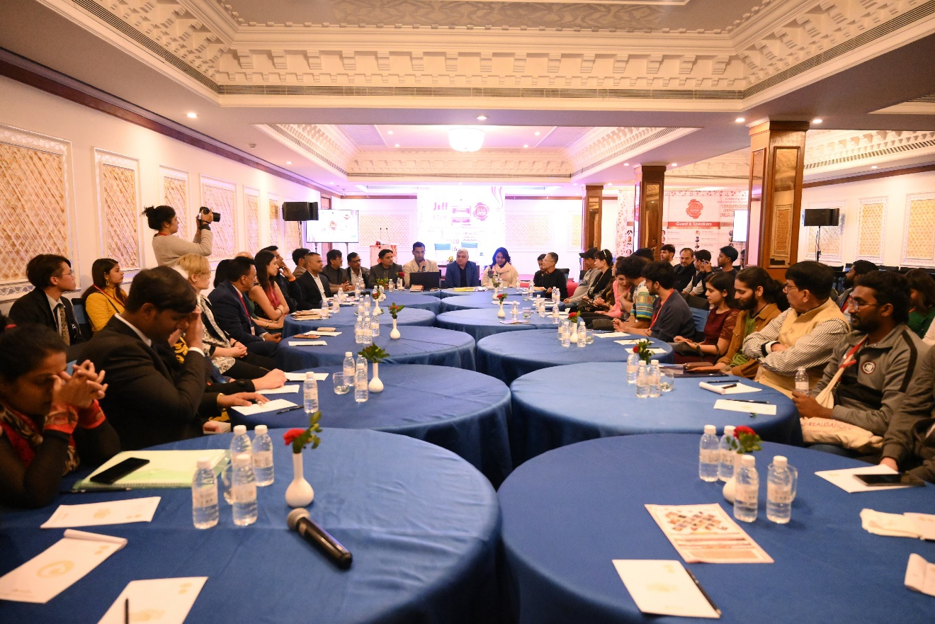
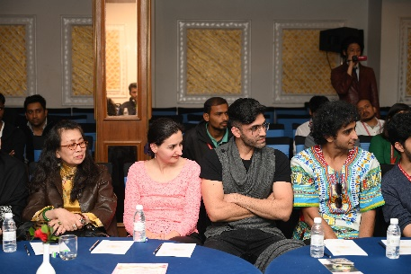
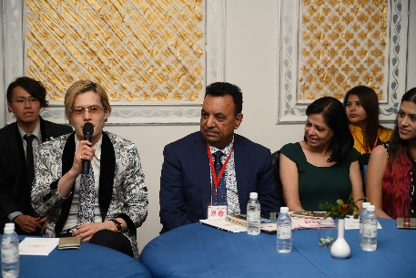
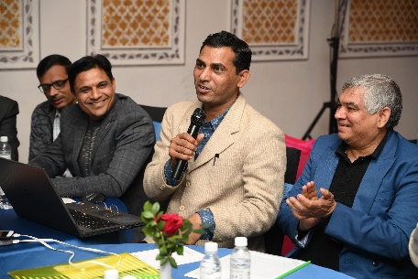

2019 INTERNATIONAL CO PRODUCTION MEET

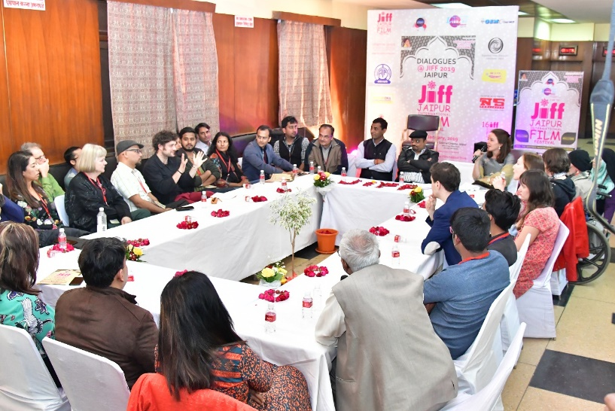
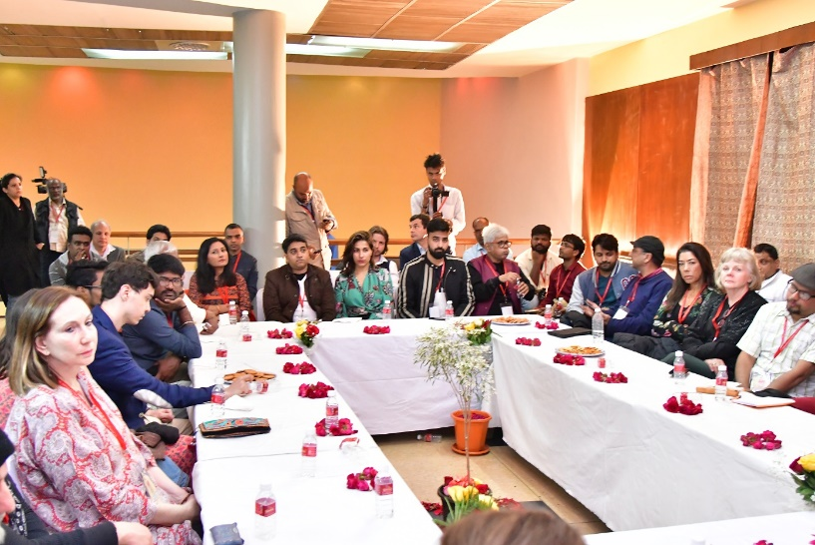
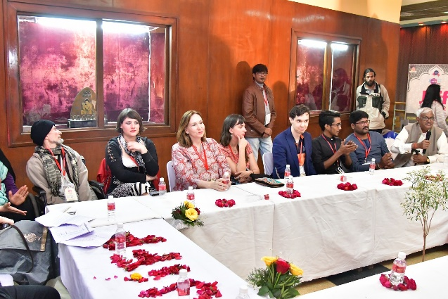
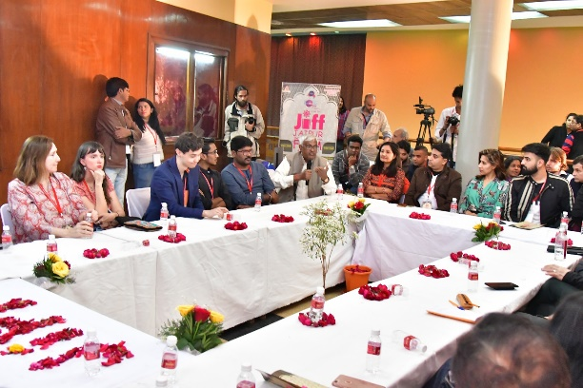

2018 INTERNATIONAL CO PRODUCTION MEET

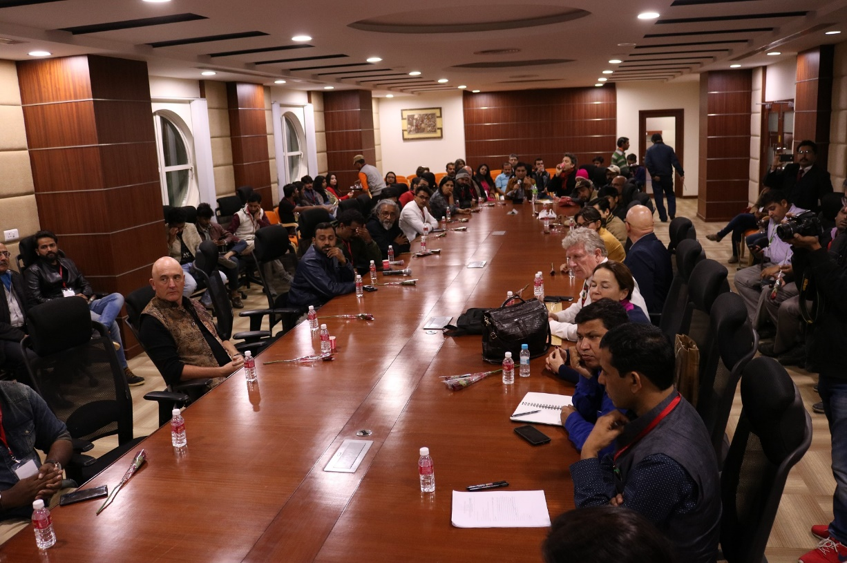

ORGANISED BY
Jaipur International Film Festival Trust
As a not-for-profit organisation
Registered under 12A & 80G
(Support this festival & take benefit under 80G)

Your donations are ultimately for the Cinema, Tourism, Art and Culture
We need continuous efforts for promotion, conservation and preservation. Film is an art form that integrates several art forms. Therefore, it needs bigger efforts for promotion, conservation and preservation. We are moving on the path of promoting and executing these ideas.

Every donation to JIFF TRUST is eligible for 50% deduction under Section 80G of the Indian Income Tax. By donating to JIFF TRUST.

Be a part of World’s Largest & Most Secure Film Library
& Library Academy Awards
(For Membership and Film Submission)
For more: - http://jaipurfilmmarket.org/coproduction.php
http://worldslargestfilmlibrary.org/

