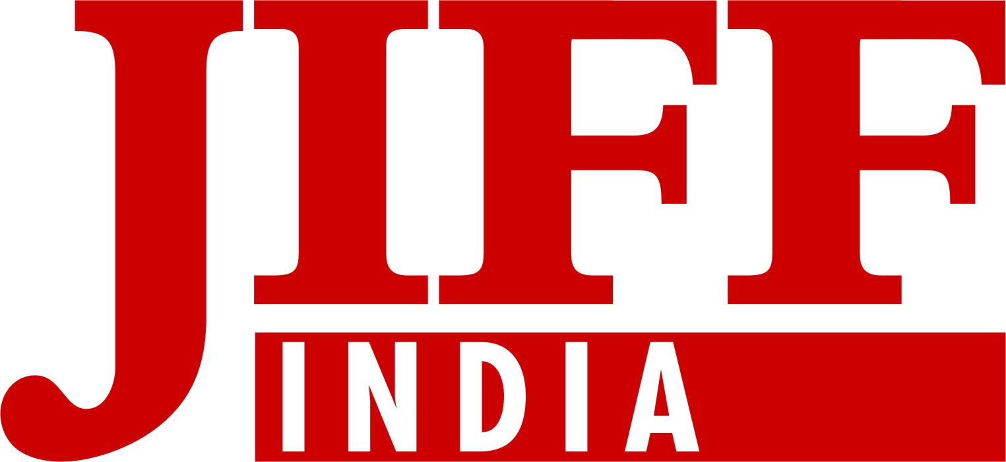
Jaipur International Film Festival
7, Jai Jawan Colony 1st, JLN Road, Jaipur-302018 Ph: +141-6500601
www.jiffindia.org, jiffindia@gmail.com, info@jiffindia.org
........................................................................................................................
PRESS RELEASE
National Film Awards via JIFF
JIFF makes its mark in mere 3 years
JIFF makes its way through to the line of World best festivals.

Jaipur, 21st of May: 3 years is not a huge time for a festival to leave its significant mark. Jaipur International Film Festival JIFF has just done that. 3 editions of JIFF have been organised till now and in all of them, the awarded films have received the national award in the same category. 3 films which were awarded in National Film Awards 2010 announced on 19th of May 2011, have been awarded in JIFF2011. Also, the films awarded in JIFF’s first two editions were awarded with National Award. This hatrick in span of three years can make any festival proud.
Possibly, JIFF would be the first International Film Festival whose awarded films have won the same awards at the Nationals and also JIFF would probably be a route for films to get awarded in National Awards in near future. These awards are a result of a right decision making by JIFF’s preview committee and the jury. JIFF’s director Hanu Roj says that just before 3 hours of the award function, he checks the decision of the jury and no other person even knows about it. Now, you can see the results of our transparent decision making.
Following films have received National Awards after being awarded at the Jaipur international Film Festival:
- JIFF2009: Karna Motcham (Short Film)- Director: S.Murli Manohar
Best short film award in JIFF and then National Award.
- JIFF2010: Garud (Short Film)- Director: Deepu.S.Unni
Best Cinematography award in JIFF and National Award in same category.

- JIFF2011:
- Veettilekkulla Vazhi (The way home) Feature Film- Director: Dr.Biju
Best Malayalam Film at National Award and screened in Jaipur International Film Festival.
- Mala Aai Vahhaychy (I want to be a mother) Feature Film Director: Samrouddhi Porey
Best Female Actor and Debutant Director at JIFF and best Marathi film award at National Film Awards.
- I am Kalam(Feature Film) Director: Nila Madhab Panda
National award for Best child artist and selected at Jaipur International Film Festival.
After winning the National Award, Dipu.S.Unni said that JIFF has helped me in gaining confidence and also in achieving my dream to be a good cinematographer.
Samrouddhi Porey told Hindustan Times, Jaipur International Film Festival has not only become a meeting point for new comers and new entrants to see films and meet the directors from different part of the world, but also to learn the art of film making and direction from films.
After winning the national award, Samrouddhi said that definitely winning two awards at JIFF has been a great achievement for her and the result of that is National Award.
Dr.Biju is very happy after winning the national award. He says that screening of my film at the festival is a great achievement for me .I will be sending my films to JIFF in future also.
Now, more and more film makers from India and outside will show their inclination towards JIFF. Till now, we had kept our festival away from glamour so that we could make its foundation really strong. Also, now Bollywood’s participation will increase in JIFF which would help in achieving JIFF’s aims.
JIFF family wants to thank all the talented film makers, preview committee, the jury members and other members of film fraternity because without their support this would always have been in the list of targets to be achieved. Along with this JIFF appeals to the international film community to keep giving their ongoing and continuous support.

This news has made one thing very clear that very serious and talented film makers are associated to JIFF and that they believe in the mission of the festival. JIFF will never ever break their trust.
Participation of 67 countries in JIFF 2011 had already brought JIFF to an international platform. Now JIFF has made its way through to the line of world’s best film festivals.
We also hear and see a lot of film makers, male and female actors and other members from film fraternity work laboriously to win national award but are not able to achieve it. Now, JIFF will help them in achieving success and will give them a new identity because now JIFF is a proven route to National Film Awards.
JIFF plans to screen the 2009,2010,2011 awarded films to be screened for the layman and also plans to organize a fabulous party on the occasion of such a news.
For now, JIFF has publicized itself in Iran and FESTIVAL DE CANNES and now is preparing to reach America, Canada and also other festivals in the home country. Till now around 15 national and international organisations have sent proposals to us for partnership and cross promotion. This proves the fact that not only in India but also international film makers have chosen JIFF as a new option and are giving us their support all throughout. There is no question about the fact that very soon JIFF will emerge as the best Film Festival in the whole world. Next month, some new and stunning concepts are going to be announced as a part of Jaipur International Film Festival i.e. International Film Festivals Association, which would surely be a new experiment for all the other film makers and film festivals.

JIFF MEDIA ROOM
Director

(HANU ROJ)
Jaipur International Film Festival
O9252259601 0141-6500601

